

Group 6

Energy Experts

Energy Demand Project

Thomas Camilli, Tj Cilvick, Melissa Duff, Julianna Iannini, Zane Mrazek, Matthew Volpe, and Michael Wertz

Contact Information

Thomas: [camillt1@tcnj.edu](mailto:camillt1@tcnj.edu)

TJ: [cilvict1@tcnj.edu](mailto:cilvict1@tcnj.edu)

Melissa: [duffm1@tcnj.edu](mailto:duffm1@tcnj.edu)

Julianna: [ianninj1@tcnj.edu](mailto:ianninj1@tcnj.edu)

Zane: [mrazekz1@tcnj.edu](mailto:mrazekz1@tcnj.edu)

Matthew: [volpem4@tcnj.edu](mailto:volpem4@tcnj.edu)   
Michael: [wertzm1@tcnj.edu](mailto:wertzm1@tcnj.edu)

**Executive Summary**

**Inception: "Executive Summary"**: This will be about one or two pages long. It should include:

* Need: To give the college and its stakeholders an organized way to view data about energy demands, aiding them in identifying patterns and drawing conclusions on the factors and different energy sources to help reduce cost. This can be applied other large universities and organizations.
  + Paul Romano
  + Energy Demand
* Approach: Focusing on creating a very user friendly and accessible application to ensure ease of use.
  + Heavy focus on accessibility
  + Simplicity of program ensuring low cost
* Benefits: Our product is an extremely low cost alternative to expensive energy management softwares or utilizing full stack web developer to create a customized program
* Cost: New cutting-edge website
  + Our Cost: 20 hours of free labor
  + External Cost: 20-25 hours at market rate of $75-$100 an hour

**Elaboration: Project Proposal and Specifications**:

### Problem Statement

Identify trends in energy demand from a versatile database for TCNJ campus buildings regarding energy costs, energy usage types, building types, building age, and occupancy for TCNJ campus buildings. There needs to be a more efficient way to view this data and draw conclusions from patterns in the database.

### Objective of the Module

* What are the best indicators of cost of energy demand based on the available indicators such as energy costs, usage types, building types, building age, and occupancy for TCNJ campus buildings?
* What patterns or trends exist in the stated indicators that relate to the associated cost with energy demand?
* A tool for giving information on the data of the energy across The College of New Jersey college campus.

### Description of Desired End Product

A database back-end and web-based UI/website that has multiple types of users.

* Admins should be able to modify/add/delete data from the database and manage the list of users.
* Ordinary users should be able to request data and identify patterns and trends in a visual format.
* Use Case 1: Allow user to search for any date for electricity and any date for natural gas with the following returned for each:
  + Yearbuilt
  + PropertyType
  + GrossFloorArea
  + Occupancy
  + NumBuildings
  + OperationalHours
  + NumComputerLabs
  + Cost
  + Usage

Transaction Requirements: Transactions are primarily used when updating data rather than retrieving. The data for the most part remains constant and will hardly ever change so there is no need for extensive design of transactions. For example, a building’s gross floor area will only change if that building happens to get an addition built on it which is very rare.

### Importance and Need for the Module

The database should be able to have users query it and pull information from it. This format should make it easier for the stakeholders to understand the relationships between the factors impacting energy demand.

### Research Plan

We will use the provided spreadsheets to obtain the necessary data for the database that we will be constructing. For any further research into energy demand, we will either reach out to Paul Romano (our stakeholder) or use the internet to bridge any gaps in our information. Some gaps in the information we hope to bridge include the meter values for each building as well as the content of each building that could impact usage and energy costs.

**Some variables we would like to include in our module include** square footage, building type, budgeted cost per month (to be chosen by the user), meter ID, meter name, and energy source (natural gas or electricity).

### Other Existing Systems

The only other system that allows users to view this data would be the provided spreadsheets. This is a highly inefficient way to access the data, since it requires manually looking through thousands of lines of information and no easy way to identify trends/patterns.

### Possible Other Applications

The format of this database could be applied/refactored to many other areas where the same data is available, allowing others to draw their own conclusions about trends in energy demand in their area. Such areas might be other universities or corporate campuses to help identify the economic and environmental factors of energy demand. It could also be used as an aid in things like real estate investment to help get an idea of the costs associated with the buildings being purchased.

### Performance

We won’t have to worry about this aspect of the project, since the data samples will be relatively small, so PostgreSQL won’t have any performance issues retrieving or doing any other operations on the data.

### Security

GitHub should be able to provide some limited security to our code, since there is developer privacy. We’re also using a VM which will have authentication/authorization. Once the project leaves GitHub’s protection and is delivered to TCNJ facilities, we will have a login system and users with the admin status to change user permissions or delete unnecessary accounts.

### Backup and Recovery

In regards to version control, GitHub will allow us to backup previous versions of the code and make branches so in the event that we lose some portion of our code, we can always fall back upon older versions and recover them. Our group should plan to save their code to the repository often (and in separate branches) so it is organized and up-to-date, also preventing possible merge conflicts. Once the project leaves GitHub’s protection and is delivered to TCNJ facilities, we hope to have a backed up version of the application, possibly on the cloud/Oracle cloud/web-application portal. We could also potentially implement a decentralized/peer-to-peer connection so in case one server goes down, the application won’t be deleted/lost.

### Technologies and Database Concepts To Learn

We will have a number of database concepts to learn for the completion of this project, such as PostgreSQL and how to write SQL schemas, which can be learned through reading the textbook and taking notes in class. We will also practice making ER diagrams and learn how to use querying in SQL, implementing certain operations such as delete, update/modify, and making transactions. We can also use the internet to learn how to make a proper UI for our database.

**Proposal Pitch Presentation**: Your presentation slides.

[ACC/CSC Stage 2](https://docs.google.com/presentation/d/1AodtdFum8qHpSkoYjCqAiAgN-HHFEqzofdg6b5c_LXo/edit?usp=sharing)

**Elaboration: Design**: This consists of the materials submitted for Stage III, with revisions clearly identified.

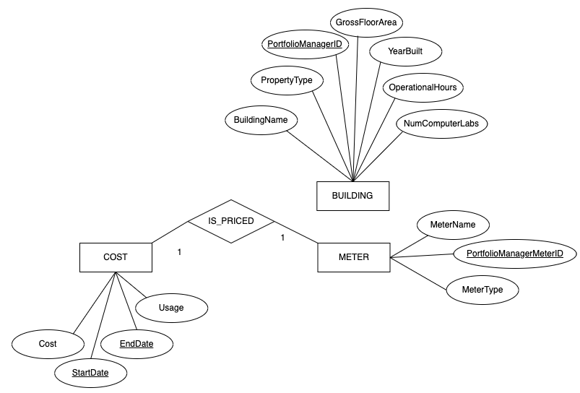

Removed the connection between meter and building. Removed a variety of unnecessary attributes. Removed meter type, usage units, month, day, and year from cost. Removed units from meters. We removed the units because we had the intention to hard code them in. Removed number of buildings, parent property id, and occupancy from building and added number of computer labs. 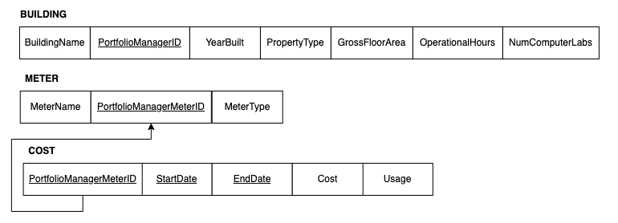

**Mid-Semester Project Presentation**: Your presentation slides.

[Stage III CSC/ACC](https://docs.google.com/presentation/d/1bLF4aj9uG7Rub8KtdQ173a2ovIslImKTBq6uekAIDIE/edit?usp=sharing)

**Construction: Tables, Queries, and User Interface**: This consists of the submissions for Stage V, with revisions clearly identified.

* Scripts for back-end (Stage 5a) can be found in “src/scripts”
  + build_db.sh - the overarching script that creates the database and calls other scripts “create_tables.sql”, “obtain_data.py”, “insert_data.sql”
  + create_tables.sql - creates the three tables “buildings” “meters” “costs”
  + obtain_data.py - reads in the csv files for populating the database and creates the new file “insert_data.sql” with all of the necessary insert commands.
  + insert_data.sql - contains over a thousand lines of SQL insert commands to populate the database, generated by “obtain_data.py”
  + ex-queries.sql - performs a few basic example SQL queries to fulfill our objective.
* Front-end screenshots can be found here, depicting our UI:

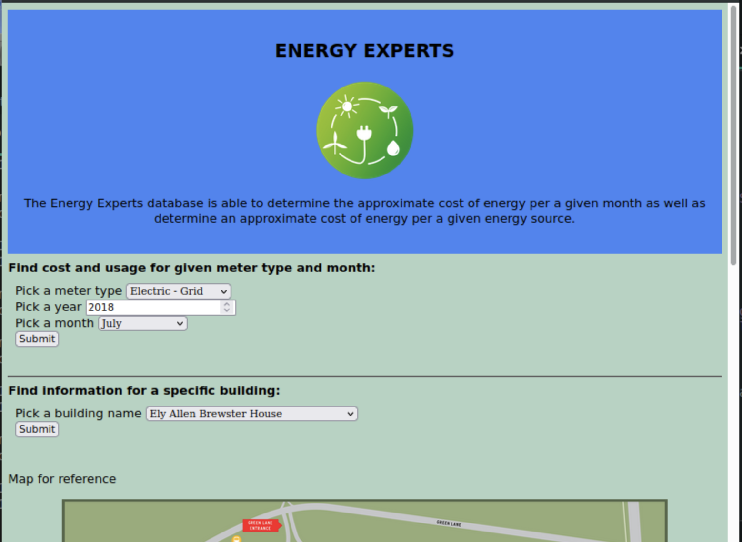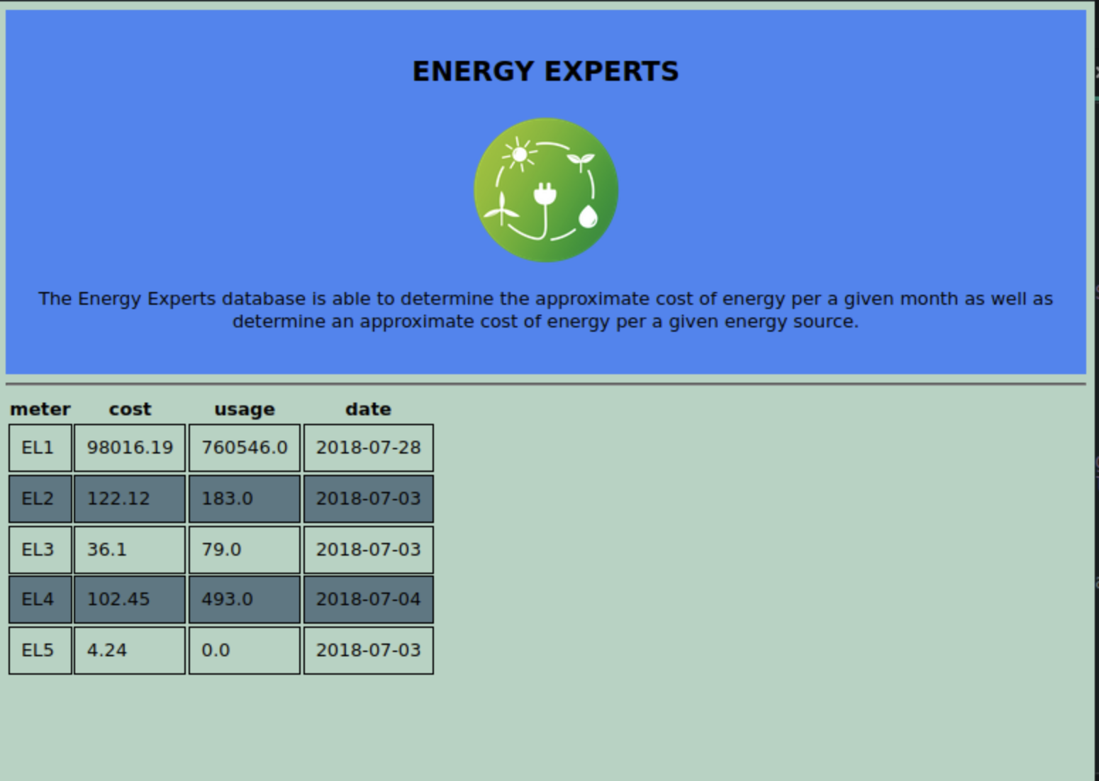

**Transition: Maintenance:** [**https://github.com/TCNJ-degoodj/cab-project-02-6**](https://github.com/TCNJ-degoodj/cab-project-02-6)

This section of the Project Report is simply your private GitHub project URL. It is satisfied if your GitHub project is complete:

* A detailed README.md with instructions on how to install and use your system. For examples, see <https://github.com/matiassingers/awesome-readme>
* The source code is appropriately organized and documented. The final report and all other project documentation are complete and appropriately organized. The wiki is appropriately organized and references the source code and documentation